Lt. Gov. Calley to lead effort to reform special education
Lori Higgins, Detroit Free Press 4:57 p.m. EDT October 16, 2015
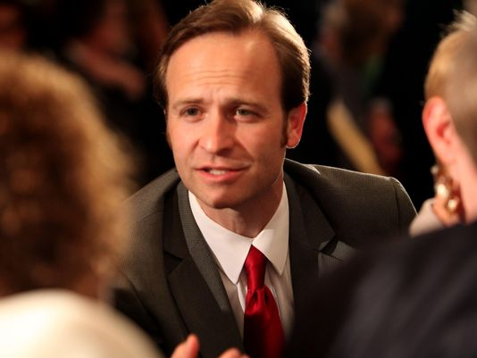
(Photo: Regina H. Boone, Detroit Free Press)
Gov. Rick Snyder has created a task force that will recommend reforms to Michigan's special education system, following a broad set of recommendations made by Lt. Gov. Brian Calley last month.
Calley spent much of this year holding listening sessions across the state, hearing from parents, teachers, administrators and special education advocates.
In a report released Sept. 8, Calley called for the state to improve the quality of services provided to special education students, make the process for changing special education rules more transparent, create a better system to resolve disputes to avoid costly lawsuits, and provide more support services for parents. He also called for legislation that would limit the use of seclusion and restraint on children in schools to emergency situations only.
The task force will make recommendations by the end of the year to address the findings in Calley's report, according to a news release from the governor's office.
"This group will help us remain focused on putting Michigan's special needs children and their families front-and-center when considering reforms to this vital component in our educational system," Snyder said in the release.
In addition to Calley, the task force will include:
- Melody Arabo, elementary teacher, Walled Lake Schools, Michigan Teacher of the Year for 2014-15
- Mary Bouwense, president, Grand Rapids Education Association, veteran special education teacher
- Elmer Cerano, executive director, Michigan Protection and Advocacy Service
- Teri Chapman, director of the office of special education, Michigan Department of Education
- Michelle Fecteau, member, State Board of Education
- Diane Heinzelman, director of special education for the Charlevoix-Emmet Intermediate School District and chair of the Michigan Autism Council
- State Sen. Hoon-Yung Hopgood, D-Taylor, member of the Senate Education Committee
- Laura Jones, founder, Special Education Advocacy & Development
- Scott Koenigsknecht, superintendent, Ingham Intermediate School District
- State Rep. Frank Liberati, D-Allen Park, member of the House Committee on Families, Children and Seniors
- Marcie Lipsitt, founder, Michigan Alliance for Special Education
- Karen McPhee, Snyder education adviser
- State Sen. Phil Pavlov, R-St. Clair Township, chair of the Senate Education Committee
- State Rep. Jim Tedder, R-Clarkston, member of the House Education Committee
- Eileen Weiser, member, State Board of Education

